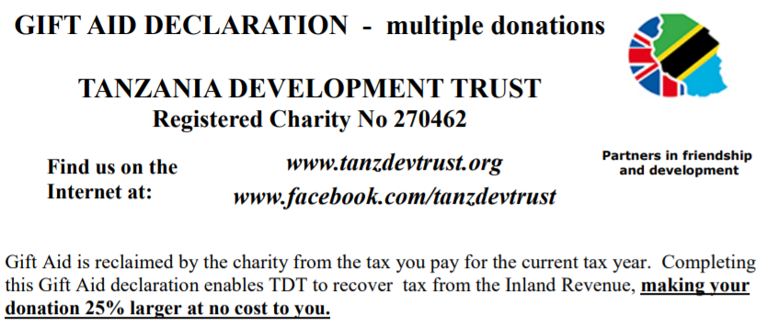
I wish to Gift Aid my donation of and any donations I make in the future or have made in the past 4 years to Tanzania Development Trust
I am a UK taxpayer and understand that if I pay less Income Tax and/or Capital Gains Tax than the amount of Gift Aid claimed on all my donations in that tax year it is my responsibility to pay any difference.
Your address is needed to identify you as a current UK taxpayer. TDT must retain these details for 6 years after the accounting period in which the last Gift Aid claim is made; the record will then be destroyed. There is no need to sign this form so you can send it back by email.
Title Forename or Initials: Surname:
Full Home address:
Post code:
Date:
Please return completed form to: treasurer@tanzdevtrust.org
(Postal address: Treasurer – TDT, 31 Blenheim Square, Lincoln LN1 3UN)
Please notify TDT if you:
• want to cancel this declaration
• change your name or home address
• no longer pay sufficient tax on your income and/or capital gains. If you pay Income Tax at the higher or additional rate and want to receive the additional tax relief due to you, you must include all your Gift Aid donations on your Self Assessment tax return or ask HM Revenue and Customs to adjust your tax code.
Many thanks for your donation, and for making it go further by adding Gift Aid.

